Monthly Run – The Craft – 344 Flaxton Drive, Flaxton, 27 August 2023
The Monthly Run in October 2019 was introduced to members by:
“Members may remember the final event for 2016 was lunch at the popular French restaurant on the Sunshine Coast, Le Relais Bressan, 344 Flaxton Drive, Flaxton. The response was fantastic and so it was thought that it was time to revisit the restaurant.”
And, from the report in the December /January 2019/20, the October 2019 event was also a great success with sixty members and guests in attendance.
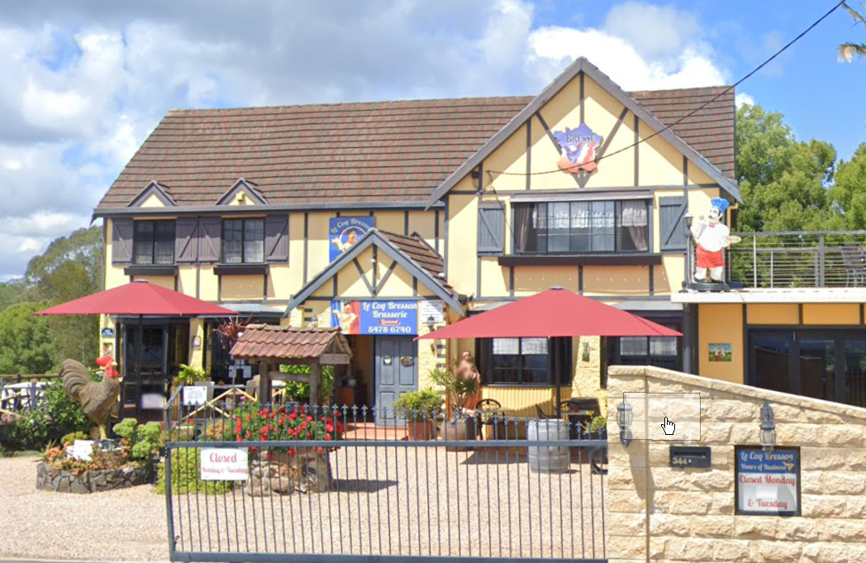
Well, almost four years later, it would seem like time that we should once again visit 344 Flaxton Drive, Flaxton. The only issue is that Le Relais Bressan has been re-incarnated as “The Craft”.
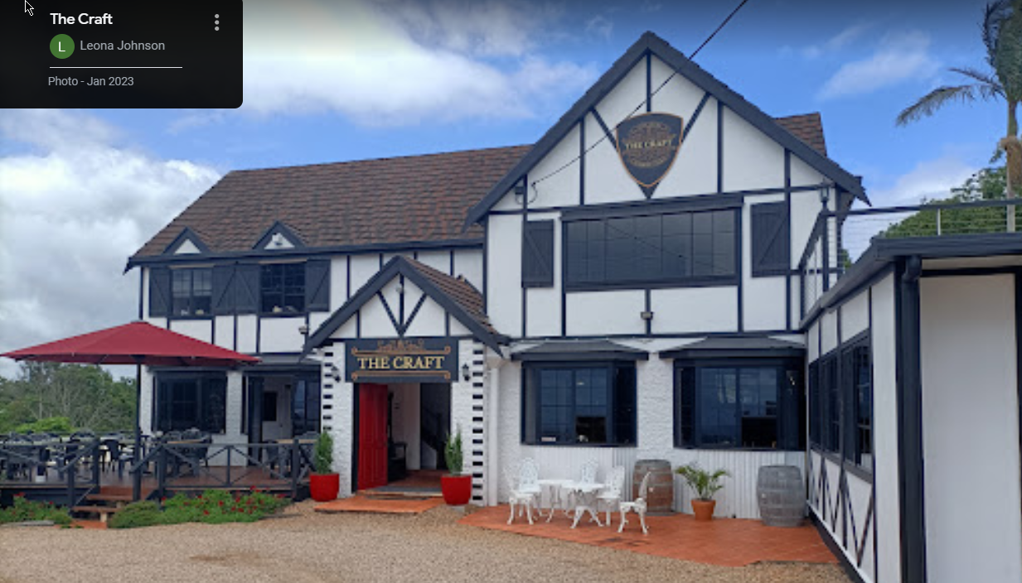
We are hoping that we will once again be in for a satisfying Alternate Drop Main and Dessert Meal at $40 each.
We will congregate once again for morning tea at Woodford, D'Aguilar Highway, park in the centre parking area opposite the Visitor Information Centre at 10:00 am.
At 10:45 am, we will depart and follow the route shown below, heading North on the Diaguilar Highway then right onto Kilcoy Beerwah Road, left onto Maleny Stanley River Road, right onto Mountain View Road, left at Landsborough Maleny Rd and right onto Maleny-Montville Road and follow the road to The Craft.
